Using The Set Operations
- Create a matrix query to display the job, the salary for that job based on department number, and the total salary for that job, for departments 10, 20, and 30, giving each column an appropriate heading.

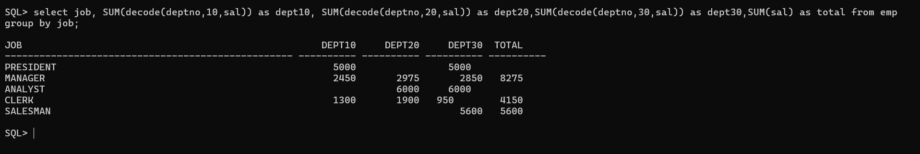

2. Using set operator display the DEPTNO, SUM(SAL) for each department, JOB, SUM(SAL) for each job and Total Salary.
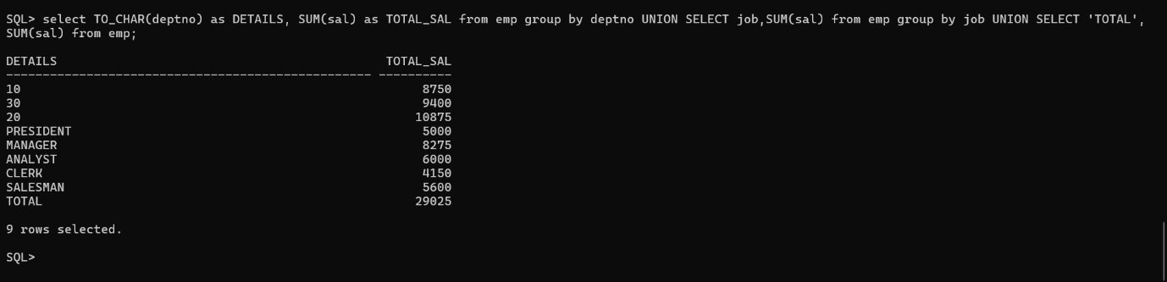

3.Using Set Operator display the JOB and DEPTNO in employees working in deptno 20, 10, 30 in that order.
